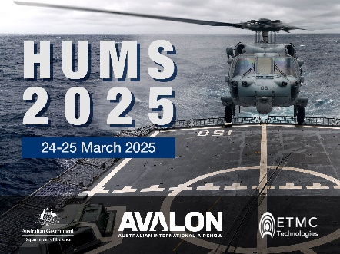

**HUMS2025 Data Challenge Result Summary**

# **Team Name**: Team01 (any name but <= 10 letters preferred)

## **Team Members**: member1, member2, member3 … (one team one submission)

## **Institutions**: University of Delta, Sigma Corporation …

## **Publishable:** Yes/No

# **Summary of Findings**

* For the early convincing detection, the HUMS2025 Committee is looking for characteristic fault features of a gearbox casing crack, which should reflect the fact that the crack is on a non-rotating casing structure. It would be more convincing if the characteristic fault features could be shown in more than one channel of the vibration dataset. Therefore, you should claim that at which file number/name that an early detection have been made convincingly.
* The early detection is to be accompanied by an accurate trending of fault propagation.
* This summary should not exceed 200 words.
* The total length of this document should not exceed **4 pages**.

# **Description of Analysis Methods**

Please succinctly describe your analysis methods in a few paragraphs, which should include fault detection method and fault trending method.

# **Key Fault Characteristics for Early Detection**

The fault characteristic feature for a gearbox casing crack should reflect the fact that the fault is on a non-rotating casing structure. It would be more convincing if key fault characteristic features can be shown in multiple channels of the vibration dataset. This should be presented with illustrating figures (captioned and/or annotated).

# **Fault Progression Trending Curve**

This curve will be compared with the estimated crack growth based on the striation marks on the fracture surface. This should be presented with illustrating figures (captioned and/or annotated).

# **Supplementary Information**

This part should present any additional important information not covered in previous sections.

**Note**: please ensure the total length of this document does not exceed **4 pages**.