Photos – HUMS2019

HUMS2019 Dinner (Tuesday 26th February 2019)
Savoy Hotel on Little Collins
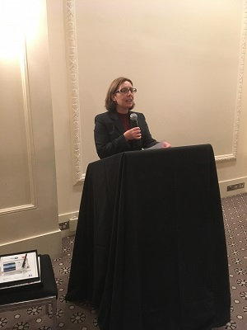  HUMS2019 Chair  Joanna Kappas | 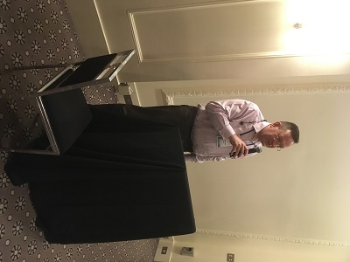  HUMS2019 Sponsor  Miroslav Dosen, ETMC Technologies
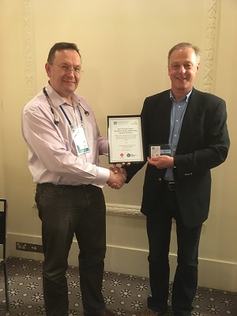  HUMS2019 Best Paper Award  Professor Chris Mechefske | 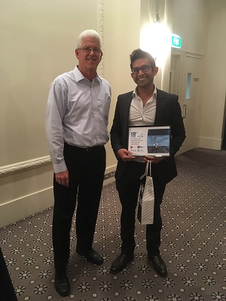  HUMS2019 Best Presentation Award  Vish Wickramanayake
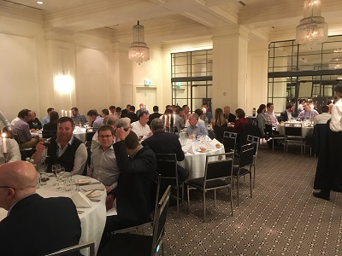 | 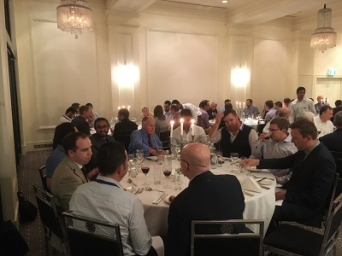
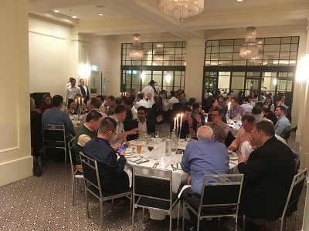 | 

